Logging in to Tableau Public

Tableau Public is a free platform to publicly share and explore data visualizations online. Anyone can create visualizations using either Tableau Desktop Professional Edition or the free Tableau Public Edition. With millions of inspiring data visualizations (or “vizzes” as we affectionately call them), anyone can check out vizzes about an array of public data topics, encouraging growth within the community.

In this reading, we will discuss how you can create a profile for using Tableau Public. We will also introduce you to some of the existing public data galleries available to you. Finally, we will end the reading with a list of resources that you can use to continue to learn about Tableau on your own.

**Creating a Tableau Public profile**

Coming up, you are going to be using Tableau Public to explore data visualizations yourself. But first, you are going to learn how to sign up for a Tableau Public profile and how to access the Google Career Certificates Gallery. This will give you access to the data visualizations created in the lesson videos. Keep in mind that once you create a profile, you can use it to access both Tableau Public as well as Tableau desktop.

To get started, go to the Tableau Public home page at [public.tableau.com](https://public.tableau.com/en-us/s/). Once you navigate to that page, you can create your account by clicking on the **Sign Up** button in the top-right corner of the screen. A pop up dialog box will appear asking you for basic profile information. Enter the requested information and click on **Create My Profile** once the button becomes available. If the button doesn’t become available, you may have missed a place where you need to fill out requested information.

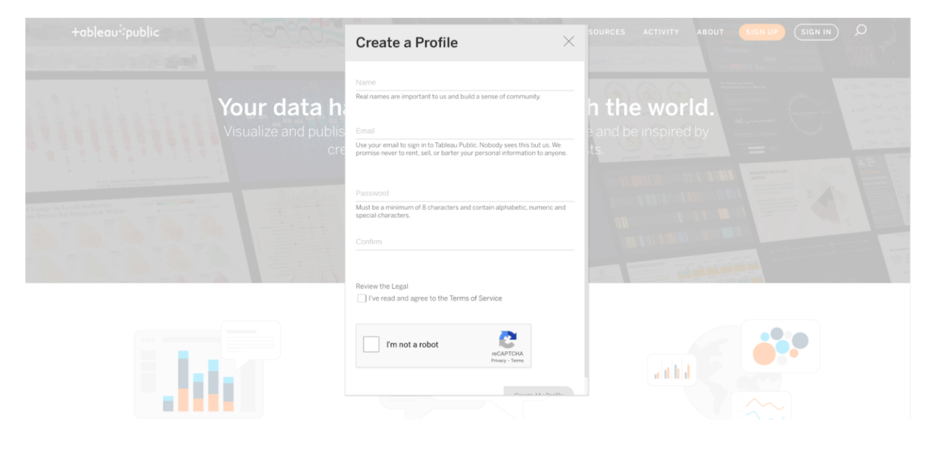

Once you have created your account, you will be able to explore public datasets and check out other creators’ work.

**Visualization galleries**

One of the coolest features of Tableau Public is the **public gallery**, where you can explore what visualizations other people have created. In addition, you have the option to explore the data behind the visualizations, as well as download visualizations that you may want to explore in detail later on. You can find the gallery from the header on the home page, or use the search function, which appears as a magnifying glass icon, to explore data and vizzes about particular topics.



Here are a few useful links within Tableau Public:

* [**Public Gallery**](https://public.tableau.com/en-us/s/viz-gallery)**:** These are data visualizations created by other users that you can scroll through.
* [**Viz of the Day**](https://public.tableau.com/en-us/gallery/?tab=viz-of-the-day&type=viz-of-the-day)**:** Tableau Public features a new data viz every day; check back for new visualizations daily!
* [**Google Career Certificates page on Tableau Public**](https://public.tableau.com/profile/grow.with.google#!/)**:** This gallery contains all of the visualizations created in the video lessons; you can explore these examples more here.
* [**Tableau Public resources page**](https://public.tableau.com/en-us/s/resources)**:** This links to the resources page, including some how-to videos and sample data.
* [**Tableau user forum**](https://community.tableau.com/s/)**:** Search for answers and connect with other users in the community on the forum page.